**OBSTACLE AVOIDING ROBOT**

AISR MINI PROJECT REPORT

Submitted by

CH.SUMANTH[9920004742]

1. VAMSI KRISHNA[9920004722]

M.SUSMITHA [9821004766]

Y.BHARGAVI[9920004740]

Under the guidance of

Dr.MANGALRAJ P

(Assistant Professor, Department of Computer Science and Engineering)

In partial fulfillment for the award of the degree

Of

BACHELOR OF TECHNOLOGY

In

COMPUTER SCIENCE AND ENGINEERING

SCHOOL OF COMPUTING

COMPUTER SCIENCE AND ENGINEERING



Kalasalingam Academy of Research and Education

Anand Nagar, Krishnankovil – 626 126

Academic Year 2022-2023

KALASALINGAM ACADEMY OF RESEARCH AND EDUCATION

(Deemed to be University)

Anand Nagar, Krishnankovil – 626 126



**BONAFIDE CERTIFICATE**

This is to certify that the Project Under the **Algorithms for Intelligent Systems and Robotics required title “OBSTACLE AVOIDANCE ROBOT”** is a Bonafide record of the work done SUMANTH,VAMSIKRISHNA,SUSMITHA AND BHARGAVIin partial fulfillment of the requirements for the award of the degree of Bachelor of Technology in Specialization of the Computer Science and Engineering, during the Academic year Odd Semester (2022-2023).

Dr.P.MANGALRAJ Dr.P.DEEPALAKSHMIM

Associate Professor & Supervisor Professor &Head Department of Department CSE of CSE

|  |  |  |  |
| --- | --- | --- | --- |
| S.NO | CHAPTER | CHAPTER  NUMBER | PAGE NUMBER |
| 1 | CHAPTER1 | OBJECTIVE |  |
| 2 | CHAPTER 2 | SCOPE OF THE PROJECT |  |
| 3 | CHAPTER 3 | INTRODUCATION |  |
| 4 | CHAPTER 4 | PROPOSED  MODEL |  |
| 5 | CHAPTER 5 | HARDWARE |  |
| 6 | CHAPTER 6 | SOFTWARE |  |
| 7 | CHAPTER 7 | FEATURE DIRECTION |  |
| 8 | CHAPTER 8 | RESULT  AND  CONCLUSION |  |

**Index**

CHAPTER 1

**OBJECTIVE**

Obstacle avoidance is one of the most important aspects of mobile robotics. Without it, robot movement would be very restrictive and fragile. This project proposes robotic vehicle that has an intelligence built in it such that it directs itself whenever an obstacle comes in its path. So, to protect the robot from any physical damages. This can be design to build an obstacle avoidance robotic vehicle using ultrasonic sensors for its movement. A micro-controller (AT mega 328P) is used to achieve the desired operation. An ultrasonic sensor is used to detect any obstacle ahead of it and sends a command to the micro-controller. Depending on the input signal received, the micro-controller redirects the robot to move in an alternate direction by actuating the motors which are interfaced to it through a motor driver.

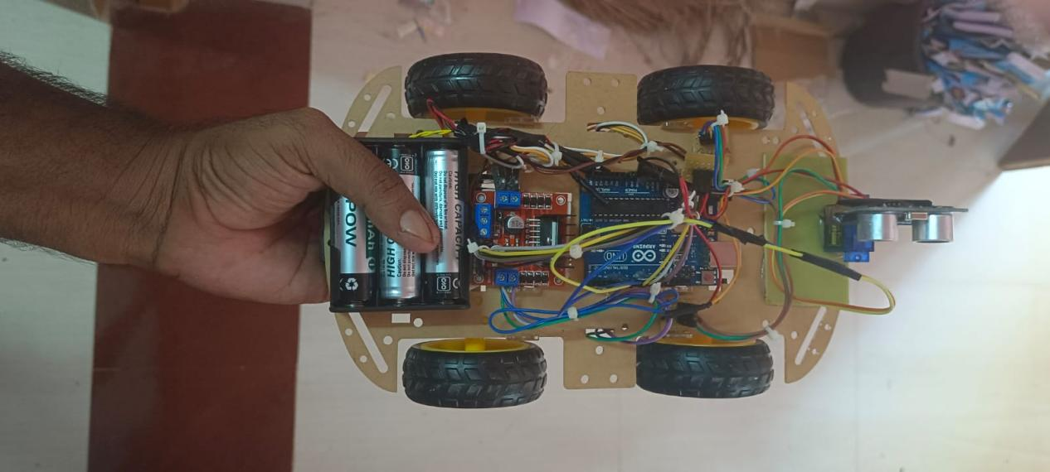

CHAPTER 2

**SCOPE OF THE PROJECT**

2.1Artificial Intelligence

Artificial Intelligence (AI) is the ability of a computer or a computer controlled-robot to think and perform tasks like humans. An artificially intelligent machine is one which is capable of learning, reasoning, planning, perception, problem solving . This field was discovered on the claim that human intelligence can be sufficiently described to the point that a machine can simulate it.

2.2Robotics and Robots

Robotics is an interdisciplinary research area at the interface of computer science and engineering. Robotics involves the design, construction, operation, and use of robots . The goal of robotics is to design intelligent machines in order to help human beings in their daily activities. This technology has resulted in automated machines that can replace humans in manufacturing processes or dangerous environments. These robots have numerous structures depending on their functions. Generally, robots are grouped into:

Manipulator robots (industrial robots)

• Mobile robots (autonomous vehicles)

• Self-reconfigurable robots, which are robots that can adjust themselves based on the task to be performed.

Robots may be designed to act on their decision-making ability or to be controlled by humans .Robots work by trying to mimic/replicate the human behaviour as they are made to possess the same components of human beings. These components include:

A muscle system in order to move the body structure

• A body structure.

• A power source used to activate sensors and muscles

• A sense system used to obtain environmental information

• A brain system which processes the sensed information and gives the muscles information on how to respond .

2.3 Robot Learning

Robot learning involves the combination of robotics and machine learning by the learning of different algorithms by the robot in order to apply techniques which will enable it to obtain skills and adjust to its surrounding. The robot learning can take place by imitation of humans or by self-learning guided by a human .

2.4 Autonomous Robot

An Autonomous robot is one that is capable of performing activities with a high level of self-control and without any form of external control. This kind of robot is achieved by integrating artificial intelligence, robotics, and information engineering . Autonomous robots, just like human beings, additionally can settle on their own choices and afterward respond accordingly. A genuinely autonomous robot is one that can sense and recognize its environment, settle on choices dependent on what it sees and afterwards, actuate a movement in response. Regarding mobility, for instance, the decision-based activities incorporate but however are not restricted to the following: starting, stopping, and manoeuvring around obstructions that are in their path. Some mobile robots utilize ultrasound sensors to detect obstacles or infrared. These sensors work in similar fashion to animal echolocation. The robot sends a beam of light or a sound signal out and observes the reflection distance by identifying how long it takes the signal to bounce back. In some advanced robots, stereo vision is used. This method uses two cameras for depth perception and image recognition in order to detect and categorize different objects. In more advanced robots, they can be able to study new environments and adjust to them. They even work on areas with uneven land as they can link land patterns with certain actions. For example, a rover robot constructs a land map by utilizing its visual sensors and if the map depicts uneven land patterns, the robot can adapt to the environment and choose to take a different path. Such kind of systems can be highly beneficial for exploration and can be used for operation on other planets.

CHAPTER 3

**INTRODUCATION**

In our world today, ROBOTICS is a very interesting research area, which is fast growing as it is the simplest way for modifying modern day technology. Robotics plays a major role in technology advancement, which is why I decided to work on the robotics field and design something intelligent to make human life simpler. An autonomous robot is one which can move without any external interference in an environment which is unstructured and unknown to the robot. The robot is able to do this because of the software intelligence embedded inside it in order for it to be able to sense the environment, detect any obstacle which is in its path and move round the environment by avoiding these obstacles [1]. In the designing of an autonomous robot, there are many robotic designs that can be used. To make a selection of the design to be used, the main factor to be put into consideration is the physical environment in which the robot will be operated. Examples of autonomous robots: walking robots, drones, robotic cars, and snake robots. The obstacle avoiding robot has enough intelligence in order for it to cover the maximum area of the space provided and it has an ultrasound sensor which is used to detect any obstacles in the path of the robot, after which it will move in a direction to avoid the obstacle [2]. The main aim of such technology is that it can play a huge role in today’s transportation as it can be used to avoid accidents, which generally happen on congested roads by applying emergency brake. If this technology is used in a car, it will automatically sense any objects (living things or objects) in the path of the car and automatically apply breaks or take a side to the available free space where necessary.

An obstacle avoiding robot is an intelligent device, which can automatically sense and overcome obstacles on its path. Obstacle Avoidance is a robotic discipline with the objective of moving vehicles on the basis of the sensorial information. The use of these methods front to classic methods (path planning) is a natural alternative when the scenario is dynamic with an unpredictable behaviour. In these cases, the surroundings do not remain invariable, and thus the sensory information is used to detect the changes consequently adapting moving. It will automatically scan the surrounding for further path.

A necessary requirement of every autonomous mobile robot is obstacle avoidance. This obstacle avoidance feature is of high importance in a robot’s navigation system in an unknown area so as to prevent collisions during its operation. It is necessary for an autonomous robot to avoid collisions in order to prevent damage to the object or to the robot itself. Application areas where obstacle avoidance is necessary include automatic vacuum cleaners and helicopters. Even in robots which work in a familiar environment and the path of the robot has been adequately defined, some environmental changes could occur and cause the robot to run into an object in its way so it is necessary for the robot to be able to adapt to the change by avoiding any objects in its path. This problem of effective trajectory planning is what has led to the need for a robot that can detect and avoid objects in a pre-computed path, or objects that appear suddenly. The solution to this trajectory problem involves the use of sensors by the robot to detect objects and avoid them thereby making the robot to be more independent since it would not require external influence.

Motivation The idea of an autonomous robot is not a new one. Every company that uses mobile robots to perform tasks would like the robot to be able to carry out its functions effectively without any external control. With the advancement in the GPS technology, achieving the independent robot movement is closer to reality. However, the concern of how the robot sees and interacts with its environment must be addressed before the robot is used. To address this concern, sensors are used to collect enough environmental data that the robot interprets for smooth navigation of the robot. This method of addressing the concern leaves three questions: is it possible for a sensor to collect enough data for collision-free movement? Also, is there a fast and effective method of interpreting this data to the robot? Lastly, after interpretation, can the robot react and make correct decisions as quick and precise as a human would in the same environment? These are questions that must be answered to allow for human-free robot movement

Aim and Objectives The Aim of this project is to design and implement a robot car that is able to move round an unknown environment without running into obstacles in its path. The Objectives of the project are as follows: The robot car should have the capacity to detect obstacles in its path based on a predetermined threshold distance. After detection of an obstacle, the robot should be able to change its direction to a relatively open path by making an autonomous decision. The robot car should not require any external control during its operation. The robot car should be able to measure distance between itself and an obstacle in real time. The robot car should be able to operate effectively in an environment which is unknown to it.

Robotics is part of today’s communication. In today’s world ROBOTICS is fast growing and interesting field. It is simplest way for latest technology modification. Now a days communication is part of advancement of technology, so we decided to work on ROBOTICS field, and design something which will make human life simpler in day today aspect. Thus we are supporting this cause. An obstacle avoiding robot is an intelligent device, which can automatically sense and overcome obstacles on its path. Obstacle Avoidance is a robotic discipline with the objective of moving vehicles on the basis of the sensorial information. The use of these methods front to classic methods (path planning) is a natural alternative when the scenario is dynamic with an unpredictable behaviour. In these cases, the surroundings do not remain invariable, and thus the sensory information is used to detect the changes consequently adapting moving. It will automatically scan the surrounding for further path. This project is basic stage of any automatic robot. This ROBOT has sufficient intelligence to cover the maximum area of provided space. It has a ultrasonic sensor which are used to sense the obstacles coming in between the path of ROBOT. It will move in a particular direction and avoid the obstacle which is coming in its path. We have used two D.C motors to give motion to the ROBOT. The construction of the ROBOT circuit is easy and small .The electronics parts used in the ROBOT circuits are easily available and cheap too.

CHAPTER 4

**PROPOSED MODEL**

**4.1 THE OBSTACLE AVOIDINCE SYSTEM**

Autonomous vehicles uses radar, GPS, computer vision, odometer and lidar to detectit surroundings. Advance control systems interpret sensory information to identify appropriate navigation part, as well as obstacles. The absence of an obstacle avoidance system in the vehicles would make all the work of the radar, GPS and other component to be useless. According to (United States of America Patent No. 4,751,658, 1988), the obstacle avoidance system is a system for avoiding obstacles in the path of a vehicle including a sensor assembly having a field view with a plurality of sectors for detecting the distance of objects within each sector. The system further includes an element for identifying obstructed sensor in which objects are detected within a predetermined range and a device for detecting unobstructed sector close in alignment to the direction of the path to designate around the object of clear path which is close to the original path. Collision avoidance system is a good example of systems which exhibit criticality in safety and concurrency. This system is safety critical in the sense that lives depend on the correct and continued interaction with the real world. The obstacle avoidance system can be considered to be an introduction to autonomous robot construction, a lot of robots would depend on this system so as to be able to work more efficient and also when implemented in automobile vehicles will enhance the reduction of automobile accident. Robotics has achieved its greatest success to date in the world of industrial manufacturing, robot arms are bolted at the shoulder to a specific location in the assembly line. The robot arm can move with great speed and accuracy to perform repetitive tasks such as spot welding and painting. In the electronics industry, manipulators place surface-mounted components with superhuman precision, making the portable telephone and laptop computer possible. Yet, for all of their successes, these commercial robots suffer from a fundamental disadvantage lack of mobility. In contrast, a mobile robot would be able to travel throughout the manufacturing plant, flexibly applying its talents wherever it is most effective. The low-level complexities of the robot often make it impossible for a human operator to directly control its motions. The human performs localization and cognition activities,but relies on the robot's control scheme to provide motion control.

This project is basically for the robot to sense things in its environment so as to stay out of trouble. The human ability to control machines (robots) is not hundred percent efficient, human operators still run robots into obstacle, hence the need for an obstacle avoidance system, which would override the command of the operator to avoid collision with solid objects in the part of the robot. The system would be implemented on a robot vehicle so as to simulate how useful it would be if our vehicles are fitted with obstacle avoidance systems.

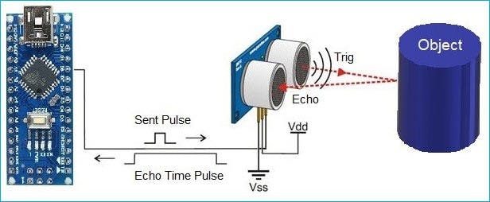

**4.2 BLOCK DIAGRAM**

**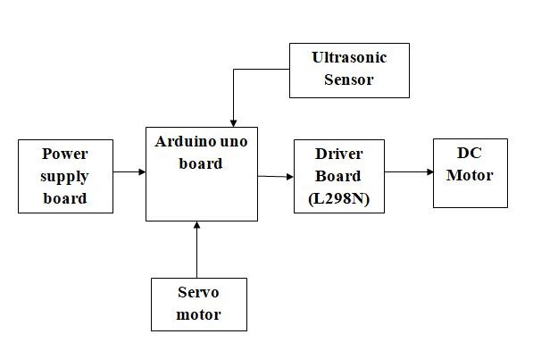**

**4.3 CIRCUIT DIAGRAM**

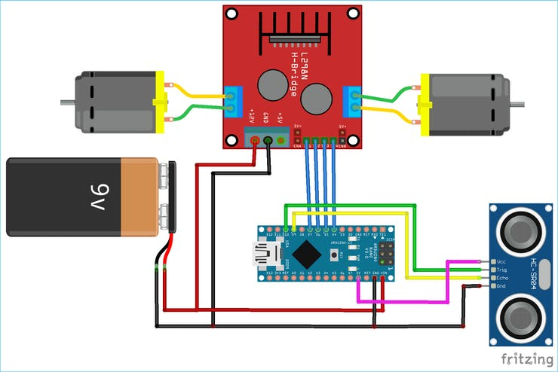

### **4.4 APPLICAⁱTIONS**

1.Obstacle avoiding robots can be used in almost all mobile robot navigation systems.

1. They can be used for household work like automatic vacuum cleaning.

3.They can also be used in dangerous environments, where human penetration could be fatal.

CHAPTER 5

**HARDWARE**

**COMPONENTS :**

Arduino Uno R3

HC-SR04 Ultrasonic Sensor

LM298N Motor Driver Module

5V DC Motors

Battery

Wheels

Chassis

Jumper Wires

**ARDUINO UNO R3**

The Arduino Uno R3 micro controller coordinates the sensor and other components to automatically send a message necessary for help informing emergency service providers of the accident and location of accident spot. Thus, the emergency responder service can prepare and initiate the required aid in the shortest time possible. Arduino, open-hardware platform’s analog input and output channels which can be used to monitor voltages and read a wide variety of analog sensors or sample wave forms. Analogue digital converter Arduino platforms are equipped with an on-chip, multi-channel channel analog-to-digital converter (ADC). Arduino’s digital pins can serve as analog outputs by using pulse width modulation (P.W.M) techniques by toggling their digital I/O pins to produce pulse width modulated (pwm) signals. The duty cycle of each pwm output’s 490 Hz .Square wave can be programmed to deliver an equivalent r.m.s voltage between 0 and 5 v in 256, 2 m/sec increments. Inputs pins The Arduino Uno (R3) board’s analog inputs (A0-A5) And analog pwm outputs (digital 3, 5, 6, 9, 10, and 11) are physically accessed via standard header pins. It’s easy to develop code with analog I/O functions, since the programming language supported by the Arduino IDE includes a set of native analog I/O commands. These instructions enable reading analog inputs, generation of analog (pwm) outputs, and configuration of the A/D converter reference voltage.

Reading Analog inputs

Reading analog voltages using Arduino programming language involves selecting the reference source using analog reference(type) and then invoking a read analog read(pin) where (pin) indicates the header pin number you wish to sample. Once selected, the reference type remains constant until otherwise programmed. Creating pwn analog outputs. Generating an analog voltage on one of Arduino’s pwn pins requires configuring the desired pin as an output using the pin mode (pin, mode) command and then invoking an analog write (pin, value), where (pin) indicates the header pin you wish to output to and (value) is the fraction of the reference voltage to be generated .The I/O pins can support drive currents of up to 40 ma, so they can drive moderate-sized led arrays directly. The output can be filtered using a simple r/c network and used as the control voltage for an amplifier or current source. Internal comparator Arduino Uno have an internal comparator which can compare an input voltage against another external input, a voltage generated by one of the pwn outputs, or the reference device’s internal reference voltage. The compactor's output can be polled or used to trigger an interrupt. This can be very handy for this project .However ,for Arduino boards whose MCU’s do not have an internal compactor, it is relatively easy to add a an external device such as LM741.Prototyping shield cards which make it easy to add user-supplied circuitry for analog or digital I/O to nearly any standard Arduino board .



Figure 5.1 ARDUINO UNO BOARD

**Features of the Arduino UNO R3:**

• Micro controller: atmega328

• Operating voltage: 5v

• Input voltage (recommended): 7-12v

• Input voltage (limits): 6-20v

• Digital i/o pins: 14 (of which 6 provide pwn output)

• Analog input pins: 6

• Dc current per i/o pin: 40 ma

• Dc current for 3.3v pin: 50 ma

• Flash memory: 32 Kb of which 0.5 Kb used by boot loader

• Sram: 2 Kb (atmega328)

• Eeprom: 1 Kb (atmega328)

• Clock speed: 16 MHz

**Ultrasonic sensor**

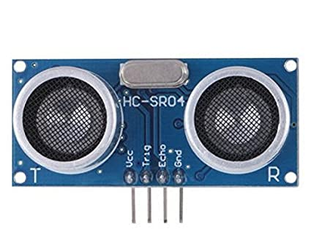

Ultrasonic sensors are electronic devices that calculate the target’s distance by emission of ultrasonic sound waves and convert those waves into electrical signals. The speed of emitted ultrasonic waves traveling speed is faster than the audible sound.

There are mainly two essential elements which are the transmitter and receiver. Using the piezoelectric crystals, the transmitter generates sound, and from there it travels to the target and gets back to the receiver component.

To know the distance between the target and the sensor, the sensor calculates the amount of time required for sound emission to travel from transmitter to receiver. The calculation is done as follows:

**D = 1/2 T \* C**

Where ‘T’ corresponds to time measured in seconds

‘C’ corresponds to sound speed = 343 measured in mt/sec

**Ultrasonic sensor working principle** is either similar to sonar or radar which evaluates the target/object attributes by understanding the received echoes from sound/radio waves correspondingly. These sensors produce high-frequency sound waves and analyze the echo which is received from the [sensor](https://www.watelectronics.com/mcq/temperature-sensor/). The sensors measure the time interval between transmitted and received echoes so that the distance to the target is known.

#### Ultrasonic Sensor Specifications

Knowing the specifications of an ultrasonic sensor helps in understanding the reliable approximations of distance measurements.

* The sensing range lies between 40 cm to 300 cm.
* The response time is between 50 milliseconds to 200 milliseconds.
* The Beam angle is around 50.
* It operates within the voltage range of 20 VDC to 30 VDC
* Preciseness is ±5%
* The frequency of the ultrasound wave is 120 kHz
* Resolution is 1mm
* The voltage of sensor output is between 0 VDC – 10 VDC
* The ultrasonic sensor weight nearly 150 grams
* Ambient [temperature](https://www.watelectronics.com/temperature-sensor/" \t "_blank) is -250C to +700C
* The target dimensions to measure maximum distance is 5 cm × 5 cm

Introduction to Ultrasonic Sensor

Ultrasonic sensors work by emitting sound waves at a frequency which is too high for humans to hear. An above image shows the HC-SR-04 ultrasonic sensor which has transmitter, receiver. The pin configuration is,

• VCC – +5 V supply

• TRIG – Trigger input of sensor. Micro controller applies 10 us trigger pulse to the HC-SR04 ultrasonic module.

• ECHO–Echo output of sensor. Micro controller reads/monitors this pin to detect the obstacle or to find the distance.

• GND – Ground

Sound is a mechanical wave traveling through the mediums, which may be a solid, or liquid or gas. Sound waves can travel through the mediums with specific velocity depends on the medium of propagation. The sound waves which are having high frequency reflect from boundaries and produce distinctive echo patterns.

Features of an Ultrasonic Sensor

1. Supply voltage: 5V (DC).

2. Supply current: 15mA.

3. Modulation frequency: 40Hz.

4. Output: 0 – 5V (Output high when obstacle detected in range).

5. Beam Angle: Max 15 degrees.

6. Distance: 2 cm – 400 cm.

7. Accuracy: 0.3cm.

8. Communication: Positive TTL pulse.

Applications of an Ultrasonic Sensor

• It Uses to avoid and detect obstacles with robots like biped robot, obstacle avoider robot, path finding robot etc.

• It Used to measure the distance within a wide range of 2cm to 400cm.

• Used to map the objects surrounding the sensor by rotating it.

• Depth of certain places like wells, pits etc can be measured since the waves can penetrate through water.

**SERVO MOTOR**

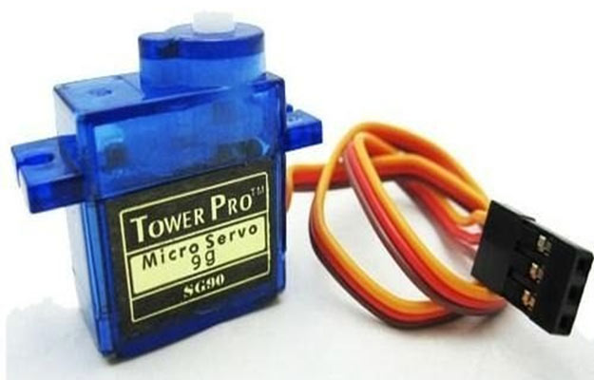

A **servo motor** is a type of motor that can rotate with great precision. Normally this type of motor consists of a control circuit that provides feedback on the current position of the motor shaft, this feedback allows the servo motors to rotate with great precision. If you want to rotate an object at some specific angles or distance, then you use a servo motor. It is just made up of a simple motor which runs through a **servo mechanism**. If motor is powered by a DC power supply then it is called DC servo motor, and if it is AC-powered motor then it is called AC servo motor. For this tutorial, we will be discussing only about the **DC servo motor working**. Apart from these major classifications, there are many other types of servo motors based on the type of gear arrangement and operating characteristics. A servo motor usually comes with a gear arrangement that allows us to get a very high torque servo motor in small and lightweight packages. Due to these features, they are being used in many applications like toy car, RC helicopters and planes, Robotics, etc.

Servo motors are rated in kg/cm (kilogram per centimeter) most hobby servo motors are rated at 3kg/cm or 6kg/cm or 12kg/cm. This kg/cm tells you how much weight your servo motor can lift at a particular distance. For example: A 6kg/cm Servo motor should be able to lift 6kg if the load is suspended 1cm away from the motors shaft, the greater the distance the lesser the weight carrying capacity.  The position of a servo motor is decided by electrical pulse and its circuitry is placed beside the motor.

### ****Servo Motor Working Mechanism****

It consists of three parts:

1. Controlled device
2. Output sensor
3. Feedback system

It is a closed-loop system where it uses a positive feedback system to control motion and the final position of the shaft. Here the device is controlled by a feedback signal generated by comparing output signal and reference input signal.

Here reference input signal is compared to the reference output signal and the third signal is produced by the feedback system. And this third signal acts as an input signal to the control the device. This signal is present as long as the feedback signal is generated or there is a difference between the reference input signal and reference output signal. So the main task of servomechanism is to maintain the output of a system at the desired value at presence of noises.

### Servo Motor Working Principle

A servo consists of a Motor (DC or AC), a potentiometer, gear assembly, and a controlling circuit. First of all, we use gear assembly to reduce RPM and to increase torque of the motor. Say at initial position of servo motor shaft, the position of the potentiometer knob is such that there is no electrical signal generated at the output port of the potentiometer. Now an electrical signal is given to another input terminal of the error detector amplifier. Now the difference between these two signals, one comes from the potentiometer and another comes from other sources, will be processed in a feedback mechanism and output will be provided in terms of error signal. This error signal acts as the input for motor and motor starts rotating. Now motor shaft is connected with the potentiometer and as the motor rotates so the potentiometer and it will generate a signal. So as the potentiometer angular position changes, its output feedback signal changes. After sometime the position of potentiometer reaches at a position that the output of potentiometer is same as external signal provided. At this condition, there will be no output signal from the amplifier to the motor input as there is no difference between external applied signal and the signal generated at potentiometer, and in this situation motor stops rotating.

## Advantages Of Servo Motor

Servo Motor advantages are:

* High output power relative to motor size and weight.
* The encoder determines accuracy and resolution.
* High efficiency. It can approach 90% at light loads.
* High torque to inertia ratio. Servo Motors can rapidly accelerate loads.
* Has 2-3 times more continuous power for short periods.
* Has 5-10 times more rated torque for short periods.
* Servo motors achieve high speed at high torque values.
* Quiet at high speeds.
* Encoder utilization provides higher accuracy and resolution with closed-loop control.

## Disadvantages Of Servo Motor

The top Servo Motor disadvantages are:

* Servos Motors requires tuning to stabilize the feedback loop.
* Servo Motor will become unpredictable when something breaks. So, safety circuits are required.
* A complex controller requires an encoder and electronic support.
* Peak torque is limited to a 1% duty cycle. Servo Motors can be damaged by sustained overload.
* Gearboxes are often required to deliver power at higher speeds.
* Higher overall system cost and the installation cost of a Servo Motor system may be higher than that of a stepper motor due to the requirement for feedback components.

**L298N DRIVER MODULE**

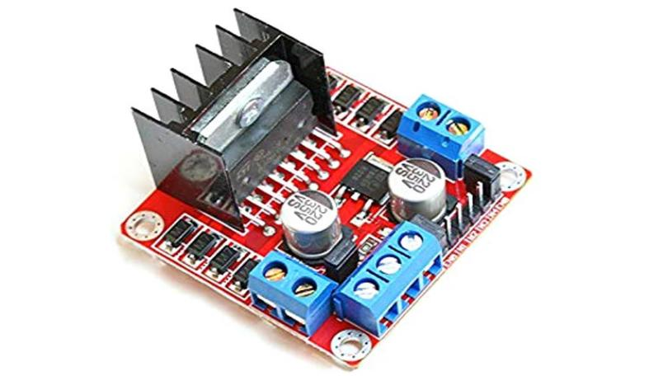

L298N module is a high voltage, high current dual full-bridge motor driver module for controlling DC motor and stepper motor. It can control both the speed and rotation direction of two DC motors. This module consists of an L298 dual-channel H-Bridge motor driver IC. This module uses two techniques for the control speed and rotation direction of the DC motors. These are PWM – For controlling the speed and H-Bridge – For controlling rotation direction. These modules can control two DC motor or one stepper motor at the same time.

### ****L298 motor driver IC****

L298 is a high voltage, high current dual full-bridge motor driver IC. It accepts standard TTL logic levels (Control Logic) and controls inductive loads such as relays, solenoids, DC and Stepper motors. This is a 15 pin IC. According to the L298 data sheet, its operating voltage is +5 to +46V, and the maximum current allowed to draw through each output 3A. This IC has two enable inputs, these are provided to enable or disable the device independently of the input signals.

A black color heat sink is attached to the L298 IC of the module. A heat sink is a passive heat exchange that transfers the heat generated by an electronic or a mechanical device to a fluid medium, often air or a liquid coolant.

### ****78M05 5V Regulator****

The module has an on-board 78M05 5V Voltage regulator. This Voltage regulator will be performed only when the **5V Enable jumper** is placed. When the power supply is less than or equal to 12V, then the internal circuitry will be powered by the voltage regulator, and the 5V pin can be used as an output pin to power the microcontroller or other circuitry (sensor).

The jumper should not be placed when the power supply is greater than 12V and separate 5V should be given through 5V terminal to power the internal circuitry.

## ****L298N Motor Driver Module Pin Diagram****

|  |  |  |
| --- | --- | --- |
| **Pin No.** | **Pin Name** | **Description** |
| **Power Supply Pins** | | |
| 1 | **VCC** | VCC pin is used to supply power to the motor. Its input voltage is between 5 to 35V. |
| 2 | **GND** | GND is a ground pin. It needs to be connected to the power supply ground(negative). |
| 3 | **+5V** | +5V pin supplies power for the switching logic circuitry inside the L298N IC. If the 5V-EN jumper is in place, this pin acts as output and can be used to power up a microcontroller or other circuitry (sensor). If the 5V-EN jumper is removed, you need to connect it to the 5V power supply of the microcontroller. |
| **Control Pins** | | |
| 1 | **IN1** | These pins are input pins of **Motor A**. These are used to control the rotating direction of Motor A. When one of them is HIGH and the other is LOW, Motor A will start rotating in a particular direction. If both the inputs are either HIGH or LOW the Motor A will stop. |
| 2 | **IN2** |
| 3 | **IN3** | These pins are input pins of **Motor B**. These are used to control the rotating direction of Motor A. When one of them is HIGH and the other is LOW, Motor A will start rotating in a particular direction. If both the inputs are either HIGH or LOW the Motor A will stop. |
| 4 | **IN4** |
| **Speed Control Pins** | | |
| 1 | **ENA** | ENA pin is used to control the speed of **Motor A**. If a jumper is present on this pin, so the pin connected to +5 V and the motor will be enabled, then the Motor A rotates maximum speed.  if we remove the jumper, we need to connect this pin to a PWM input of the microcontroller. In that way, we can control the speed of Motor A. If we connect this pin to Ground the Motor A will be disabled. |
| 2 | **ENB** | ENB pin is used to control the speed of **Motor B**. If a jumper is present on this pin, so the pin connected to +5 V and the motor will be enabled, then the Motor B rotates maximum speed.  if we remove the jumper, we need to connect this pin to a PWM input of the microcontroller. In that way, we can control the speed of Motor B. If we connect this pin to Ground the Motor B will be disabled. |
| **Output Pins** | | |
| 1 | **OUT1** & **OUT2** | This terminal block will provide the output for **Motor A**. |
| 2 | **OUT3** & **OUT4** | This terminal block will provide the output for **Motor B**. |

## ****How Motor Driver Module Works****

This module uses two techniques for the control speed and rotation direction of the DC motors. These are H-Bridge – For controlling rotation direction and PWM – For controlling the speed.

### ****H-Bridge Techniques****

L298n motor driver module uses the H-Bridge technique to control the direction of rotation of a DC motor. In this technique, H-Bridge controlled DC motor rotating direction by changing the polarity of its input voltage.

An H-Bridge circuit contains four switching elements, like transistors (BJT or MOSFET), with the motor at the center forming an H-like configuration. Input**IN1, IN2, IN3, and IN4** pins actually control the **switches** of the H-Bridge circuit inside L298N IC.

We can change the direction of the current flow by activating two particular switches at the same time, this way we can change the rotation direction of the motor.

### ****PWM (Pulse Width Modulation) Techniques****

L298n motor driver module uses the PWM technique to control the speed of rotation of a DC motor. In this technique, the speed of a DC motor can be controlled by changing its input voltage.

Pulse Width Modulation is a technique where the average value of the input voltage is adjusted by sending a series of ON-OFF pulses. The average voltage is proportional to the width of the pulses, these pulses known as Duty Cycle.

If the duty cycle higher, then the average voltage is applied to the DC motor (High Speed), and the lower the duty cycle, the less the average voltage being applied to the dc motor(Low Speed).

## ****Module Specifications & Features****

|  |  |
| --- | --- |
| **Parameter** | **Value** |
| Operating Voltage | 5V – 46V |
| Operating Current | 2A |
| Logic Voltage | 5V |
| Logical Current | 0-36mA |
| Maximum Power (W) | 25W |
| Driver Chip | L298 dual-channel H-Bridge motor driver IC |
| LED lights indicators | Power-On LED indicator |
| Drives motor | Drives up to 4 motors (2 for each motor output terminal block) or One Stepper Motor |
| Module Dimensions | 44 x 44 x 28 (LxWxH)mm |

## ****Applications :****

Control DC motors.

Control stepping motors

In Robotics

**Power Supply Board**

A **power supply** is an electrical device that supplies [electric power](https://en.wikipedia.org/wiki/Electric_power" \o "Electric power) to an [electrical load](https://en.wikipedia.org/wiki/Electrical_load" \o "Electrical load). The main purpose of a power supply is to convert [electric current](https://en.wikipedia.org/wiki/Electric_current" \o "Electric current) from a source to the correct [voltage](https://en.wikipedia.org/wiki/Voltage" \o "Voltage), [current](https://en.wikipedia.org/wiki/Electric_current" \o "Electric current), and [frequency](https://en.wikipedia.org/wiki/Frequency" \o "Frequency) to power the load. As a result, power supplies are sometimes referred to as [electric power converters](https://en.wikipedia.org/wiki/Electric_power_converter" \o "Electric power converter). Some power supplies are separate standalone pieces of equipment, while others are built into the load appliances that they power. Examples of the latter include power supplies found in [desktop computers](https://en.wikipedia.org/wiki/Desktop_computer" \o "Desktop computer) and [consumer electronics](https://en.wikipedia.org/wiki/Consumer_electronics" \o "Consumer electronics) devices. Other functions that power supplies may perform include limiting the current drawn by the load to safe levels, shutting off the current in the event of an [electrical fault](https://en.wikipedia.org/wiki/Electrical_fault" \o "Electrical fault), power conditioning to prevent [electronic noise](https://en.wikipedia.org/wiki/Electronic_noise" \o "Electronic noise) or [voltage surges](https://en.wikipedia.org/wiki/Voltage_surge" \o "Voltage surge) on the input from reaching the load, [power-factor correction](https://en.wikipedia.org/wiki/Power-factor_correction" \o "Power-factor correction), and storing energy so it can continue to power the load in the event of a temporary interruption in the source power ([uninterruptible power supply](https://en.wikipedia.org/wiki/Uninterruptible_power_supply" \o "Uninterruptible power supply)).

All power supplies have a *power input* connection, which receives energy in the form of electric current from a source, and one or more *power output* or **rail** connections that deliver current to the load. The source power may come from the [electric power grid](https://en.wikipedia.org/wiki/Electric_power_grid" \o "Electric power grid), such as an [electrical outlet](https://en.wikipedia.org/wiki/Electrical_outlet" \o "Electrical outlet), [energy storage](https://en.wikipedia.org/wiki/Energy_storage" \o "Energy storage) devices such as [batteries](https://en.wikipedia.org/wiki/Battery_(electricity)" \o "Battery (electricity)) or [fuel cells](https://en.wikipedia.org/wiki/Fuel_cell" \o "Fuel cell), [generators](https://en.wikipedia.org/wiki/Electrical_generators" \o "Electrical generators) or [alternators](https://en.wikipedia.org/wiki/Alternator" \o "Alternator), [solar power](https://en.wikipedia.org/wiki/Solar_power" \o "Solar power) converters, or another power supply. The input and output are usually hardwired circuit connections, though some power supplies employ [wireless energy transfer](https://en.wikipedia.org/wiki/Wireless_power" \o "Wireless power) to power their loads without wired connections. Some power supplies have other types of inputs and outputs as well, for functions such as external monitoring and control.

### Types

### DC power supplies

An AC-to-DC power supply operates on an AC input voltage and generates a DC output voltage. Depending on application requirements the output voltage may contain large or negligible amounts of AC frequency components known as [ripple voltage](https://en.wikipedia.org/wiki/Ripple_voltage" \o "Ripple voltage), related to AC input voltage frequency and the power supply's operation. A DC power supply operating on DC input voltage is called a [DC-to-DC converter](https://en.wikipedia.org/wiki/DC-to-DC_converter" \o "DC-to-DC converter). This section focuses mostly on the AC-to-DC variant.

#### Linear power supply

[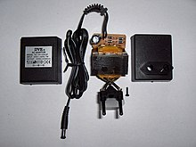](https://en.wikipedia.org/wiki/File:Wall_wart_opened.JPG)

An AC adapter disassembled to reveal a simple, unregulated linear DC supply circuit: a transformer, four diodes in a [bridge rectifier](https://en.wikipedia.org/wiki/Diode_bridge" \o "Diode bridge) arrangement, and an [electrolytic capacitor](https://en.wikipedia.org/wiki/Electrolytic_capacitor" \o "Electrolytic capacitor) to smooth the waveform

In a linear power supply the AC input voltage passes through a [power transformer](https://en.wikipedia.org/wiki/Power_transformer" \o "Power transformer) and is then rectified and filtered to obtain a DC voltage. The filtering reduces the amplitude of AC mains frequency present in the rectifier output and can be as simple as a single capacitor or more complex such as a [pi filter](https://en.wikipedia.org/wiki/Pi_filter" \o "Pi filter). The electric load's tolerance of ripple dictates the minimum amount of filtering that must be provided by the power supply. In some applications, ripple can be entirely ignored. For example, in some battery charging applications, the power supply consists of just a transformer and a diode, with a simple resistor placed at the power supply output to limit the charging current.

#### Switched-mode power supply

In a [switched-mode power supply](https://en.wikipedia.org/wiki/Switched-mode_power_supply" \o "Switched-mode power supply) (SMPS), the AC mains input is directly rectified and then filtered to obtain a DC voltage. The resulting DC voltage is then switched on and off at a high frequency by electronic switching circuitry, thus producing an AC current that will pass through a [high-frequency](https://en.wikipedia.org/wiki/High-frequency" \o "High-frequency) transformer or inductor. Switching occurs at a very high frequency (typically 10 kHz — 1 MHz), thereby enabling the use of [transformers](https://en.wikipedia.org/wiki/Transformer" \o "Transformer) and filter capacitors that are much smaller, lighter, and less expensive than those found in linear power supplies operating at mains frequency. After the inductor or transformer secondary, the high frequency AC is rectified and filtered to produce the DC output voltage. If the SMPS uses an adequately insulated high-frequency transformer, the output will be [electrically isolated](https://en.wikipedia.org/wiki/Galvanic_isolation" \o "Galvanic isolation) from the mains; this feature is often essential for safety.

Switched-mode power supplies are usually regulated, and to keep the output voltage constant, the power supply employs a feedback controller that monitors current drawn by the load. The switching [duty cycle](https://en.wikipedia.org/wiki/Duty_cycle" \o "Duty cycle) increases as power output requirements increase.

SMPSs often include safety features such as current limiting or a [crowbar circuit](https://en.wikipedia.org/wiki/Crowbar_(circuit)" \o "Crowbar (circuit)) to help protect the device and the user from harm.[[1]](https://en.wikipedia.org/wiki/Power_supply" \l "cite_note-1) In the event that an abnormal high-current power draw is detected, the switched-mode supply can assume this is a direct short and will shut itself down before damage is done. PC power supplies often provide a *[power good](https://en.wikipedia.org/wiki/Power_good" \o "Power good)* signal to the motherboard; the absence of this signal prevents operation when abnormal supply voltages are present.

Some SMPSs have an absolute limit on their minimum current output.[[2]](https://en.wikipedia.org/wiki/Power_supply" \l "cite_note-2) They are only able to output above a certain power level and cannot function below that point. In a no-load condition the frequency of the power slicing circuit increases to great speed, causing the isolated transformer to act as a [Tesla coil](https://en.wikipedia.org/wiki/Tesla_coil" \o "Tesla coil), causing damage due to the resulting very high voltage power spikes. Switched-mode supplies with protection circuits may briefly turn on but then shut down when no load has been detected. A very small low-power [dummy load](https://en.wikipedia.org/wiki/Dummy_load" \o "Dummy load) such as a ceramic power resistor or 10-watt light bulb can be attached to the supply to allow it to run with no primary load attached.

The switch-mode power supplies used in computers have historically had low [power factors](https://en.wikipedia.org/wiki/Power_factor" \o "Power factor) and have also been significant sources of line interference (due to induced [power line harmonics](https://en.wikipedia.org/wiki/Power_system_harmonics" \o "Power system harmonics) and transients). In simple switch-mode power supplies, the input stage may distort the line voltage waveform, which can adversely affect other loads (and result in poor power quality for other utility customers), and cause unnecessary heating in wires and distribution equipment. Furthermore, customers incur higher electric bills when operating lower power factor loads. To circumvent these problems, some computer switch-mode power supplies perform power factor correction, and may employ input filters or additional switching stages to reduce line interference.

#### Capacitive (transformerless) power supply

A [capacitive power supply](https://en.wikipedia.org/wiki/Capacitive_power_supply" \o "Capacitive power supply) (transformer less power supply) uses the reactance of a [capacitor](https://en.wikipedia.org/wiki/Capacitor" \o "Capacitor) to reduce the mains voltage to a smaller AC voltage. Typically, the resulting reduced AC voltage is then rectified, filtered and regulated to produce a constant DC output voltage.

The output voltage is not isolated from the mains. Consequently, to avoid exposing people and equipment from hazardous high voltage, anything connected to the power supply must be reliably insulated.

The voltage reduction capacitor must withstand the full mains voltage, and it must also have enough capacitance to support maximum load current at the rated output voltage. Taken together, these constraints limit practical uses of this type of supply to low-power applications.

#### Linear regulator

The function of a *[linear voltage regulator](https://en.wikipedia.org/wiki/Linear_regulator" \o "Linear regulator)* is to convert a varying DC voltage to a constant, often specific, lower DC voltage. In addition, they often provide a [current limiting](https://en.wikipedia.org/wiki/Current_limiting" \o "Current limiting) function to protect the power supply and load from over current (excessive, potentially destructive current).

A constant output voltage is required in many power supply applications, but the voltage provided by many energy sources will vary with changes in load impedance. Furthermore, when an unregulated DC power supply is the energy source, its output voltage will also vary with changing input voltage. To circumvent this, some power supplies use a linear voltage regulator to maintain the output voltage at a steady value, independent of fluctuations in input voltage and load impedance. Linear regulators can also reduce the magnitude of ripple and noise on the output voltage.

### AC power supplies

An AC power supply typically takes the voltage from a wall outlet ([mains supply](https://en.wikipedia.org/wiki/Mains_supply" \o "Mains supply)) and uses a transformer to step up or step down the voltage to the desired voltage. Some filtering may take place as well. In some cases, the source voltage is the same as the output voltage; this is called an [isolation transformer](https://en.wikipedia.org/wiki/Isolation_transformer" \o "Isolation transformer). Other AC power supply transformers do not provide mains isolation; these are called [autotransformers](https://en.wikipedia.org/wiki/Autotransformer" \o "Autotransformer); a variable output auto transformer is known as a [variac](https://en.wikipedia.org/wiki/Variac" \o "Variac). Other kinds of AC power supplies are designed to provide a nearly [constant current](https://en.wikipedia.org/wiki/Current_source" \o "Current source), and output voltage may vary depending on impedance of the load. In cases when the power source is direct current, (like an automobile storage battery), an [inverter](https://en.wikipedia.org/wiki/Power_inverter" \o "Power inverter) and step-up transformer may be used to convert it to AC power. Portable AC power may be provided by an [alternator](https://en.wikipedia.org/wiki/Alternator" \o "Alternator) powered by a diesel or gasoline engine (for example, at a construction site, in an automobile or boat, or backup power generation for emergency services) whose current is passed to a regulator circuit to provide a constant voltage at the output. Some kinds of AC power conversion do not use a transformer. If the output voltage and input voltage are the same, and primary purpose of the device is to filter AC power, it may be called a [line conditioner](https://en.wikipedia.org/wiki/Line_conditioner" \o "Line conditioner). If the device is designed to provide backup power, it may be called an [uninterruptable power supply](https://en.wikipedia.org/wiki/Uninterruptable_power_supply" \o "Uninterruptable power supply). A circuit may be designed with a [voltage multiplier](https://en.wikipedia.org/wiki/Voltage_multiplier" \o "Voltage multiplier) topology to directly step-up AC power; formerly, such an application was a vacuum tube [AC/DC receiver](https://en.wikipedia.org/wiki/AC/DC_receiver" \o "AC/DC receiver).

In modern use, AC power supplies can be divided into [single phase](https://en.wikipedia.org/wiki/Single-phase_electric_power" \o "Single-phase electric power) and [three phase](https://en.wikipedia.org/wiki/Three-phase" \o "Three-phase) systems. AC power Supplies can also be used to change the frequency as well as the voltage, they are often used by manufacturers to check the suitability of their products for use in other countries. 230 V 50 Hz or 115 60 Hz or even 400 Hz for avionics testing.

#### AC adapter

[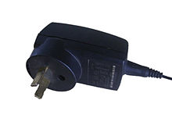](https://en.wikipedia.org/wiki/File:Switched_mode_power_adapter.jpg)

Switch-mode mobile phone charger

An uninterruptible power supply (UPS) takes its power from two or more sources simultaneously. It is usually powered directly from the AC mains, while simultaneously charging a storage battery. Should there be a dropout or failure of the mains, the battery instantly takes over so that the load never experiences an interruption. Instantly here should be defined as the speed of electricity within conductors which is somewhat near the speed of light. That definition is important because transmission of high speed data and communications service must have continuity/NO break of that service. Some manufacturers use a quasi standard of 4 milliseconds. However, with high speed data even 4 ms of time in transitioning from one source to another is not fast enough. The transition must be made in a break before make method. The UPS meeting that requirement is referred to as a True UPS or a Hybrid UPS. How much time the UPS will provide is most often based on batteries and in conjunction with generators. That time can range from a quasi minimum 5 to 15 minutes to hours or even days. In many computer installations, it is only enough time on batteries to give the operators time to shut down the system in an orderly way. Other UPS schemes may use an internal combustion engine or turbine to supply power during a utility power outage and the amount of battery time is then dependent upon how long it takes the generator to be on line and the criticality of the equipment served. Such a scheme is found in hospitals, data centers, call centers, cell sites and telephone central offices.

### High-voltage power supply

A **high-voltage power supply** is one that outputs hundreds or thousands of volts. A special output connector is used that prevents [arcing](https://en.wikipedia.org/wiki/Arcing" \o "Arcing), insulation breakdown and accidental human contact. Federal Standard connectors are typically used for applications above 20 KV, though other types of connectors (e.g., [SHV connector](https://en.wikipedia.org/wiki/SHV_connector" \o "SHV connector)) may be used at lower voltages. Some high-voltage power supplies provide an analog input or digital communication interface that can be used to control the output voltage. High-voltage power supplies are commonly used to accelerate and manipulate electron and ion beams in equipment such as [x-ray generators](https://en.wikipedia.org/wiki/X-ray_generator" \o "X-ray generator), [electron microscopes](https://en.wikipedia.org/wiki/Electron_microscope" \o "Electron microscope), and [focused ion beam](https://en.wikipedia.org/wiki/Focused_ion_beam" \o "Focused ion beam) columns, and in a variety of other applications, including [electrophoresis](https://en.wikipedia.org/wiki/Electrophoresis" \o "Electrophoresis) and [electrostatics](https://en.wikipedia.org/wiki/Electrostatics" \o "Electrostatics).

High-voltage power supplies typically apply the bulk of their input energy to a [power inverter](https://en.wikipedia.org/wiki/Power_inverter" \o "Power inverter), which in turn drives a [voltage multiplier](https://en.wikipedia.org/wiki/Voltage_multiplier" \o "Voltage multiplier) or a high turns ratio, high-voltage transformer, or both (usually a transformer followed by a multiplier) to produce high voltage. The high voltage is passed out of the power supply through the special connector and is also applied to a [voltage divider](https://en.wikipedia.org/wiki/Voltage_divider" \o "Voltage divider) that converts it to a low-voltage *metering* signal compatible with low-voltage circuitry. The metering signal is used by a closed-loop controller that regulates the high voltage by controlling inverter input power, and it may also be conveyed out of the power supply to allow external circuitry to monitor the high-voltage output.

**Specification**

The suitability of a particular power supply for an application is determined by various attributes of the power supply, which are typically listed in the power supply's *specification*. Commonly specified attributes for a power supply include:

* Input voltage type (AC or DC) and range
* Efficiency of power conversion
* The amount of [voltage](https://en.wikipedia.org/wiki/Voltage" \o "Voltage) and [current](https://en.wikipedia.org/wiki/Current_(electricity)" \o "Current (electricity)) it can supply to its load
* How stable its output voltage or current is under varying line and load conditions
* How long it can supply energy without refueling or recharging (applies to power supplies that employ portable energy sources)
* Operating and storage temperature ranges

**DC MOTOR**

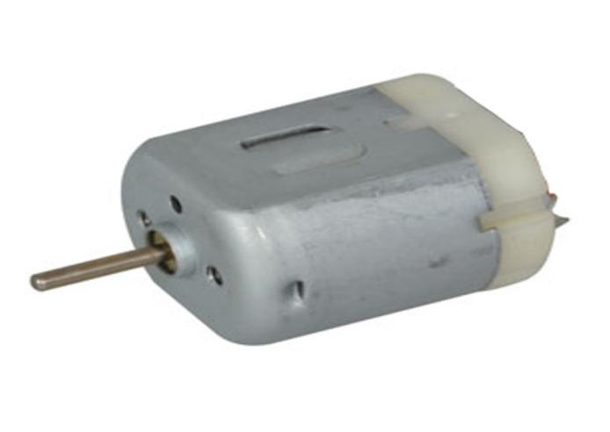

A **DC motor** is any of a class of rotary [electrical motors](https://en.wikipedia.org/wiki/Electrical_motor" \o "Electrical motor) that converts direct current (DC) electrical energy into mechanical energy. The most common types rely on the forces produced by magnetic fields. Nearly all types of DC motors have some internal mechanism, either electromechanical or electronic, to periodically change the direction of current in part of the motor.

DC motors were the first form of motor widely used, as they could be powered from existing direct-current lighting power distribution systems. A DC motor's speed can be controlled over a wide range, using either a variable supply voltage or by changing the strength of current in its field windings. Small DC motors are used in tools, toys, and appliances. The [universal motor](https://en.wikipedia.org/wiki/Universal_motor" \o "Universal motor) can operate on direct current but is a lightweight [brushed](https://en.wikipedia.org/wiki/Brush_(electric)" \o "Brush (electric)) motor used for portable power tools and appliances. Larger DC motors are currently used in propulsion of electric vehicles, elevator and hoists, and in drives for steel rolling mills. The advent of [power electronics](https://en.wikipedia.org/wiki/Power_electronics" \o "Power electronics) has made replacement of DC motors with [AC motors](https://en.wikipedia.org/wiki/AC_motors" \o "AC motors) possible in many applications.

A DC motor or direct current motor is an electrical machine that transforms electrical energy into mechanical energy by creating a magnetic field that is powered by direct current. When a DC motor is powered, a magnetic field is created in its stator. The field attracts and repels magnets on the rotor; this causes the rotor to rotate. To keep the rotor continually rotating, the commutator that is attached to brushes connected to the power source supply current to the motors wire windings.

## Two – Types of DC Motors

In order to appreciate the benefits of DC motors, it is important to understand the various types. Each type of DC motor has beneficial characteristics that must be examined before purchase and use. Two of the main advantages of DC motors over alternating current (AC) motors are how easy they are to install and that they require little maintenance.

DC motors are differentiated by the connections between the field winding and the armature. The field winding can be connected parallel to the armature or connected in a series. In some cases, the connection is both parallel and in a series.

A further distinction of DC motors is how the rotor is powered; it can be brushed or brushless. In brush DC motors, current is applied to the rotor by brushes. In a brushless DC motor, the rotor has a permanent magnet.

Since DC motors are everywhere and used for a wide variety of applications, there is a different type to meet the needs of every application. Regardless of your need for DC motors, it is important to understand each type since they can be found in every aspect of life.

### Brushed DC Motor

The magnetic field in a brush DC motor is produced by current sent through a commutator and brush that are connected to the rotor. Brushes are made of carbon and can be separately excited or self excited. The stator is the enclosure that contains the components of the motor and contains the magnetic field. The winding of the coil on the rotor can be in a series or parallel to form either a series wound DC motor or shunt wound DC motor.

The commutator is an electrical switch that reverses the current between the rotor and the external power source. It is a method of applying electrical current to the windings and produces a steady rotating torque by reversing the current direction. The sections of the commutator are attached to the winding's on the rotor through a set of contact bars that are set in the shaft of the motor.

There are three main types of DC motors: separately excited, self excited, or permanent magnet. In the separately excited and self excited, an electromagnet is used in the stator structure. With the permanent magnet type, a powerful magnet generates the magnetic field.

Self excited DC motors are further divided into shunt, series, and compound. The compound excited type is separated into cumulative and differential with short and long shunts in each type.

### Separately Excited DC Motor

In a separately excited DC motor, the motor has separate electrical supplies to the armature winding and field winding, which are electrically separate from each other. The operations of the armature current and field current do not interfere with each other‘s actions, but the input power is their total sum.

### Permanent Magnet DC Motor

A permanent magnet DC motor has an armature winding but does not have a field winding. The permanent magnet is mounted on the inner surface of the stator core to produce the magnetic field. It has a regular armature consisting of a commutator and brushes.

Permanent magnet DC motors are smaller and less expensive. They use rare earth magnets such as samarium cobalt or neodymium iron boron.

### Self Excited DC Motor

In self excited DC motors, the field and armature winding's are connected and have a single supply source. The connections are parallel or series with parallel made as shunt wound while the series version is series wound.

### Brushless DC Motor (BLDC)

Brushless DC motors, known as BLDC motors, are a permanent magnet synchronous electric motor driven by direct current and an electronically controlled commutation system, the process of producing rotational torque by changing phase currents. They are also referred to as trapezoidal permanent magnet motors.

The electrical commutation by a BLDC motor is what differentiates it from brushed DC motors that operate by mechanical contact on a rotor. A BLDC motor includes a magnet rotor and a stator with a sequence of coils. The permanent magnet rotates while current carrying conductors are fixed in position.

The armature coils are switched electronically by transistors at the correct rotor position. The created force causes the rotor to rotate. Hall sensors sense the position of the rotor and are placed on the stator. The feedback position of the rotor from the sensors determines when to switch the current of the armature.

The design of brushless DC motors eliminates the need for brushes and makes BLDC motors quieter and more reliable with an efficiency rating of 85 to 90 percent. The elimination of brushes removes the wear and tear that brushes experience since very little heat is produced by the rotating magnet.

##### Benefits of BLDC Motor

* Absence of mechanical commutator to avoid wear
* High efficiency
* High speed of operation in loaded and unloaded conditions
* Smaller motor geometry and lighter weight
* Long life
* Higher dynamic response because of low inertia and carrying winding's in the stater
* Less electromagnetic interference
* Low noise and quiet operation

## Advantages of Using DC Motors

There is an ever growing demand for DC motors, especially 12 V and 24 V models. The expanding market of solar, marine, and truck mounted equipment have come to depend on DC motor technology as an exceptionally cost effective solution. Though DC motor technology is older than AC motor technology, DC motor manufacturers are constantly developing and engineering methods to reduce motor maintenance and extend motor life.

The many types of DC motors are adaptable and adjustable to fit a wide variety of applications. It‘s important to do sufficient research to find the correct DC motor to fit the workload.

### Startup Torque

Constantly discussed in regard to DC motors is their high startup torque. For applications that need constant and consistent speed with variable torque, DC motors are the ideal choice.

### Linear Speed Torque

The curve between the torque and speed of a motor explains how fast the motor spins and how much torque it can generate. DC motors generate an exceptional speed to torque curve that is more linear than other motors.

### No Harmonic Effects

Harmonic effects degrade a power system‘s performance and reliability and may become a safety problem. When harmonic effects exist, they must be immediately identified and corrected. Damage to equipment can cause metal components to heat up and become dangerous. This particular issue is not a problem in the operation of DC motors.

### Speed Control

Another factor that is regularly discussed regarding DC motors is the ability to monitor and control their speed. When working with a heavy load system, the ability to control speed precisely and accurately ensures the success of the job. It is for this reason that DC motors are often found in paper and rolling mills where consistent speed is a necessity.

### Installation

When a DC motor is installed, it requires fewer electronic rectifications in the power system and fewer adjustments in general. Once a DC motor is installed, it can be used immediately by feeding power to it directly from the power source.

### Maintenance

The design of DC motors is simple, which makes them easy to repair or replace. DC motors have been around for over 130 years and are familiar to technicians and electricians. The many years they have been used makes them easy to diagnose and repair at very low cost.

When repairing a DC motor, there is no need for field excitation, and brushes, speed settings, and other components are easy to replace. If there is a problem with the control system, the terminal voltage can be adjusted using a potentiometer.

### Low Cost

The obvious final reason for using DC motors is their low cost; they are cheaper than AC motors, though brush less and permanent magnet DC motors are more expensive. The cost advantage of brush less motors is their exceptionally long life span. Though brush motors are less expensive, they tend to have a shorter life span and require regular repair, a negative aspect that is balanced by their low cost of repair.

**3.5 Jumper wire:**

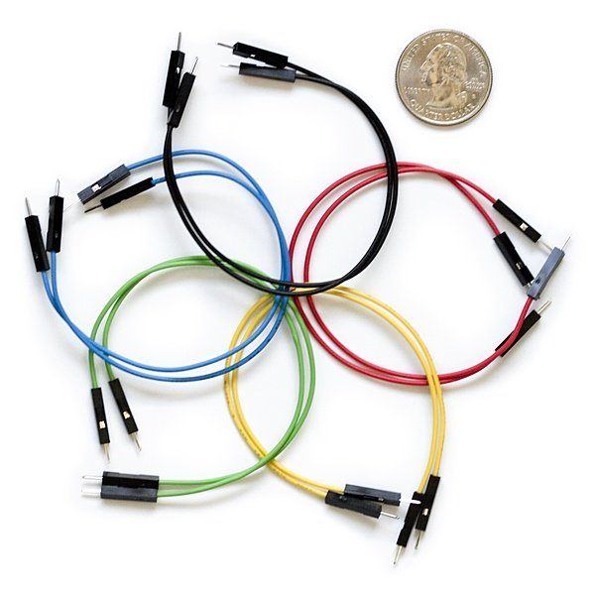

Jumper wires are simply wires that have connector pins at each end, allowing them to be used to connect two points to each other without soldering. Jumper wires are typically used with [breadboards](https://blog.sparkfuneducation.com/what-is-a-breadboard) and other prototyping tools in order to make it easy to change a circuit as needed. Fairly simple. In fact, it doesn’t get much more basic than jumper wires.

## jumper wire colorsWhat Do the Colors Mean?

Photo Credit: [oomlout](https://commons.wikimedia.org/wiki/File:A_few_Jumper_Wires.jpg)

Though jumper wires come in a variety of colors, the colors don’t actually mean anything. This means that a red jumper wire is technically the same as a black one. But the colors can be used to your advantage in order to differentiate between types of connections, such as ground or power.

## Make Your Own Jumper Wires

While jumper wires are easy and inexpensive to purchase, it can also be a fun task to [challenge students to make their own](http://www.dummies.com/programming/electronics/how-to-make-jumper-wires/). Doing so requires insulated wire and wire strippers. However, beware that it is important not to nick the wire when stripping off the insulation.

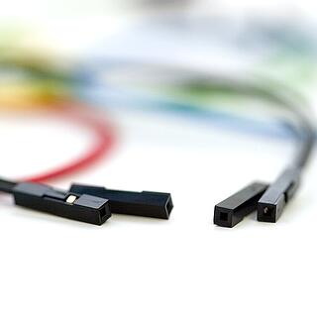Types of Jumper Wires

Jumper wires typically come in three versions: male-to-male, male-to-female and female-to-female. The difference between each is in the end point of the wire. Male ends have a pin protruding and can plug into things, while female ends do not and are used to plug things into. Male-to-male jumper wires are the most common and what you likely will use most often. When connecting two ports on a breadboard, a male-to-male wire is what you’ll need.

## Alligator Clips

[Alligator clips](https://sparkfuneducation.com/products/alligator-clips.html), which consist of two spring metal clips connected by wire, are actually just fancy jumper wires! Their unique connection point (they can be clipped on instead of inserted into) allow alligator clips to be used in a variety of situations that would get a little awkward with a traditional jumper wire. One of the most common uses for alligator clips in education is with the [MakeyMakey](https://sparkfuneducation.com/products/makey-makey.html), though they can also be used to connect the ports on a [LilyPad board](https://sparkfuneducation.com/products/lilypad-protosnap-plus.html) as well as for a number of other applications.

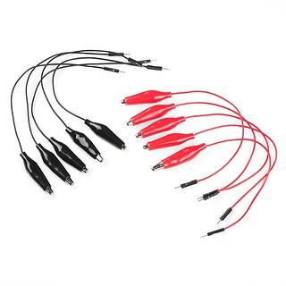

CHAPTER 6

**SOFTWARE**

OS – Windows, Linux or macOS

Language – Arduino

##### **# CODE (**Arduino)

int duration=0;

long distance=0;

int firstduration=0;

long firstdistance=0;

int secondduration=0;

long seconddistance=0;

#include <Servo.h>

Servo myservo;

int pos = 0;

void setup() {

pinMode(5,OUTPUT);

pinMode(6,INPUT);

pinMode(7, OUTPUT);

pinMode(8, OUTPUT);

pinMode(9, OUTPUT);

pinMode(10, OUTPUT);

myservo.attach(3);

Serial.begin(9600);

}

void loop()

{

digitalWrite(5, HIGH);

delayMicroseconds(10);

digitalWrite(5, LOW);

delayMicroseconds(2);

duration= pulseIn(6,HIGH);

delay(100);

distance=duration\*0.034/2;

Serial.println(distance);

if(distance<=20)

{

digitalWrite(7, LOW);

digitalWrite(8, LOW);

digitalWrite(9, LOW);

digitalWrite(10, LOW);

delay(300);

digitalWrite(7, LOW);

digitalWrite(8, HIGH);

digitalWrite(9, LOW);

digitalWrite(10, HIGH);

delay(350);

digitalWrite(7, LOW);

digitalWrite(8, LOW);

digitalWrite(9, LOW);

digitalWrite(10, LOW);

myservo.write(0);

delay(500);

digitalWrite(5, HIGH);

delayMicroseconds(10);

digitalWrite(5, LOW);

delayMicroseconds(2);

firstduration= pulseIn(6,HIGH);

delay(100);

firstdistance=firstduration\*0.034/2;

int first = firstdistance;

Serial.println(firstdistance);

myservo.write(90);

delay(500);

myservo.write(180);

delay(500);

digitalWrite(5, HIGH);

delayMicroseconds(10);

digitalWrite(5, LOW);

delayMicroseconds(2);

secondduration= pulseIn(6,HIGH);

delay(100);

seconddistance=secondduration\*0.034/2;

int second = seconddistance;

Serial.println(seconddistance);

myservo.write(90);

delay(500);

if(first < second )

{ digitalWrite(7, LOW);

digitalWrite(8, HIGH);

digitalWrite(9, HIGH);

digitalWrite(10, LOW);

delay(500); }

else if(first > second )

{

digitalWrite(7, HIGH);

digitalWrite(8, LOW);

digitalWrite(9, LOW);

digitalWrite(10, HIGH);

delay(500);

}

}

else

{

digitalWrite(7, HIGH);

digitalWrite(8, LOW);

CHAPTER 7

**FEATURE WORK**

Adding a Camera

Uses as a fire fighting robot

CHAPTER 8

**RESULT**

Arduino-controlled robot car which moves around detecting obstacles in its way and avoiding them. During operation of the robot, the ultrasonic sensor sends out an ultrasound wave to the front position (90 degrees), right position (36 degrees), and left position (144 degrees). When the wave strikes an obstacle, it bounces back and the distance is stored for the front, right, and left position. After this, the microcontroller compares the values based on its algorithm and determines whether to move forward or change path. Tests carried out on the final hardware revealed the limitations of the detection algorithm. The limitations were related to cases of some obstacles not being detected and this was as a result of the sensor not being able to measure obstacles outside the measuring range of the sensor. When an object is in the way of the car and this object is not within the line of sight of the sensor, it will not be detected thereby leading to collision. To avoid this, the testing was further carried out in an enclosed area where the wall is the only obstacle and the car was able to move freely without collision. To implement a car which will detect multiple obstacles and avoid them, more sensors have to be used in order to cover a wider range for obstacle detection.

**CONCLUSION**

This “Obstacle Avoidance Robot Car” project is proved using the Ultrasonic sensor for detecting objects, Motor Driver Shield for driving the DC motors, DC motors for movement of the wheels of the robot with the help of the Arduino Microcontroller. The factors which affect the accuracy of the designed robot include the environment the robot was tested and the number of present obstacles in the test space. These factors mainly affected the sensor which means that the accuracy of the robot is dependent on the sensor.